Write the meaning in Arabic: أكتب معنى الكلمات باللغة العربية :

|  |  |
| --- | --- |
| **Meaning معنى** | **Word كلمة** |
|  | hat |
|  | telephone |
|  | bike |
|  | chair |
|  | present |
|  | house |
|  | plane |
|  | school |
|  | cake |
|  | desk |
|  | computer |
|  | boots |

Write the words in English: أكتب اسم الكلمة باللغة الإنجليزية

1. It's a ______________ . 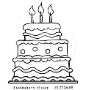
2. It's a ______________ . 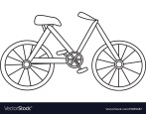

1. 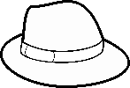It's a ______________ . 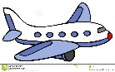
2. It's a ______________ .
3. It's a ______________ . 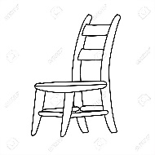
4. It's a _________________. 