* School Supplies- أغراض المدرسة

1. Watch and write: شاهد الفيديو ثم أكتب المعاني في الدفتر:

|  |  |
| --- | --- |
| **Meaning** | **Word** |
|  | pencil |
|  | eraser |
|  | sharpener |
|  | ruler |
|  | scissors |
|  | chair |
|  | desk |
|  | pen |

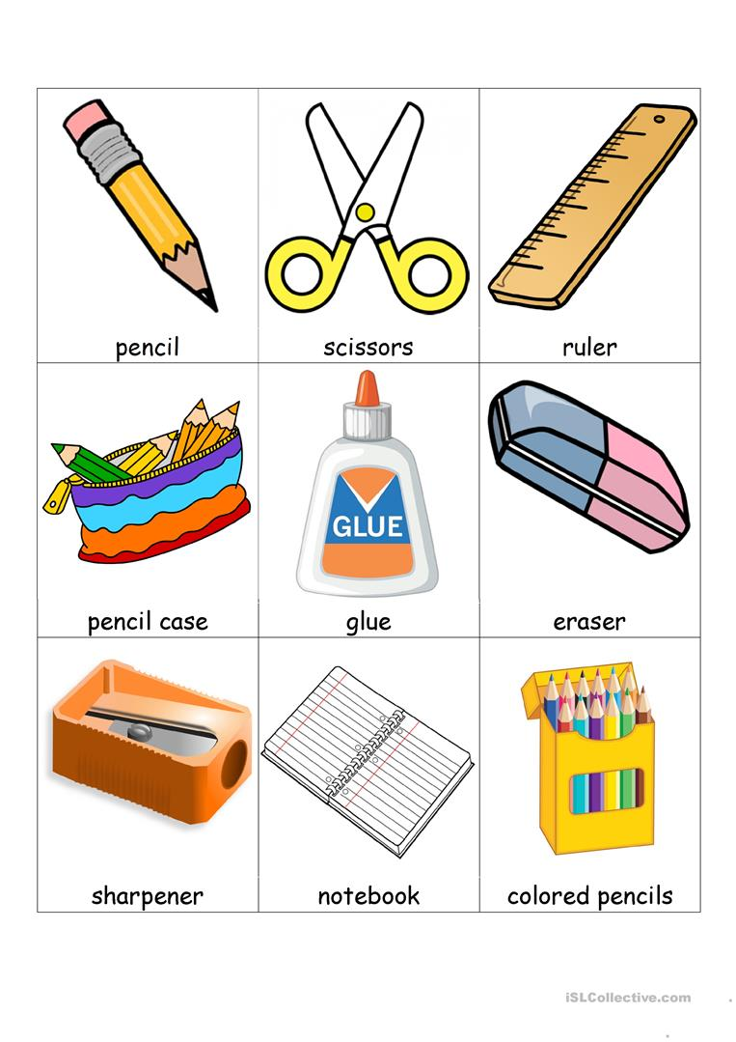

1. Write three sentences: أكتب 3 جمل عن الصورة: ماذا ترى؟
2. I can see a ________________.
3. I can see a ________________.
4. I can see a ________________.